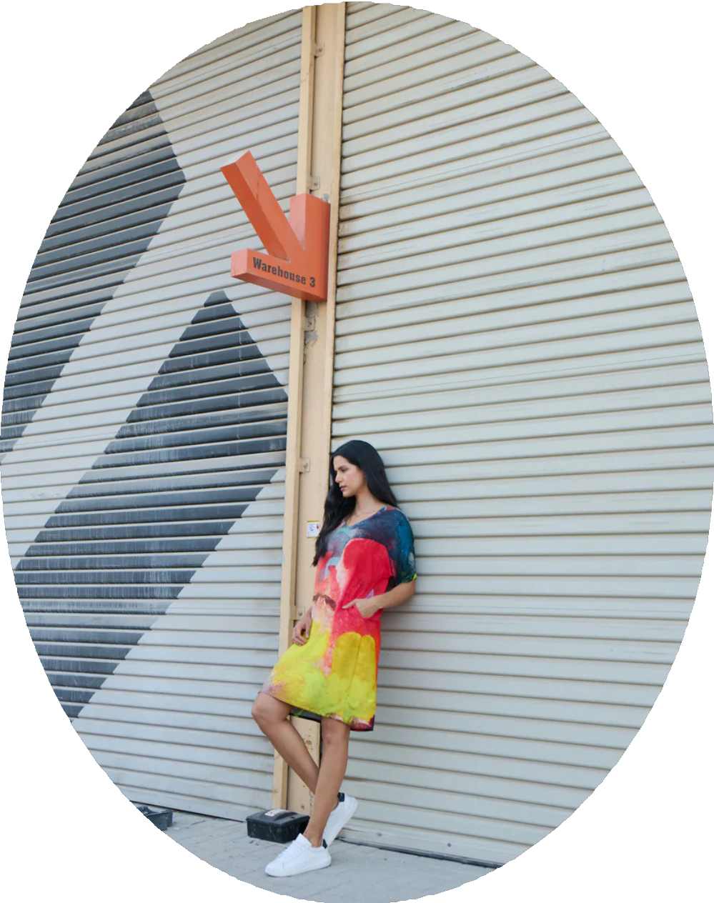
Summer Collection
DharaSheth

Summer Collection 2026
www.dharasheth.ae

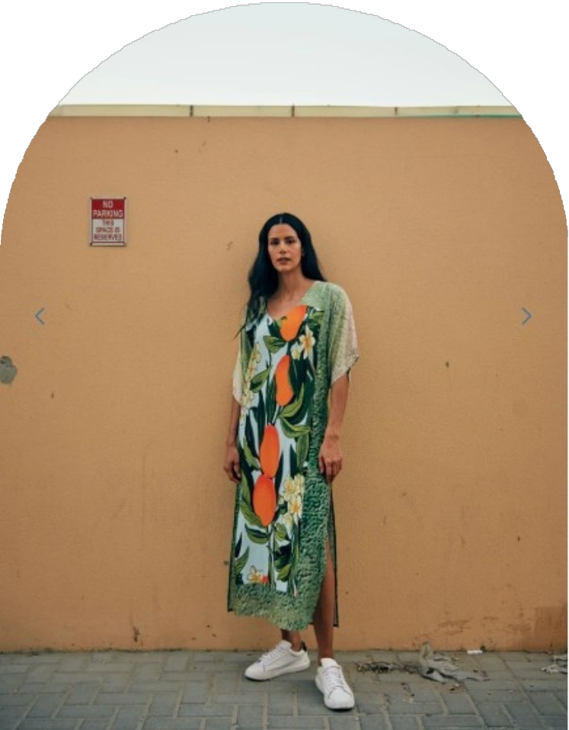
Welcome

Greetings
Elevate your warm-weather wardrobe with the Dhara Sheth Summer Collection, where effortless elegance meets vibrant, art- inspired design. This exclusive range features breezy silhouettes, lightweight fabrics, and bold prints that capture the sunny spirit of summer.

www.dharasheth.ae

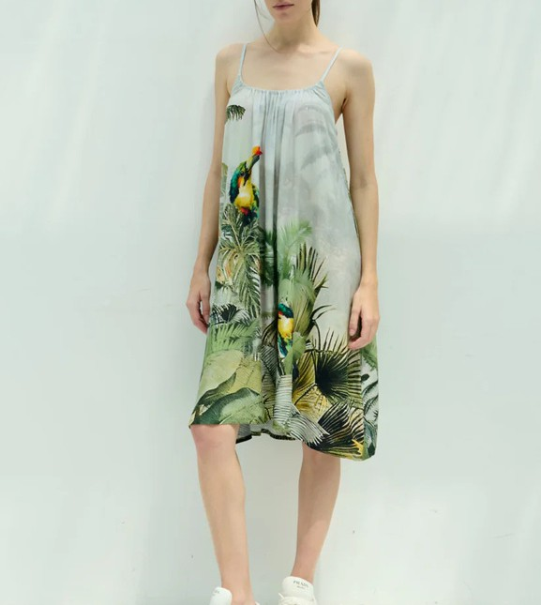
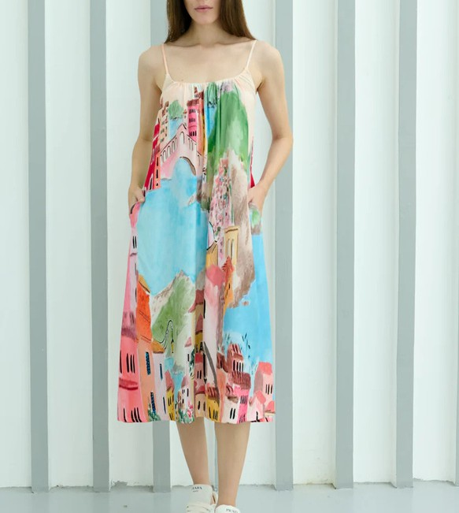
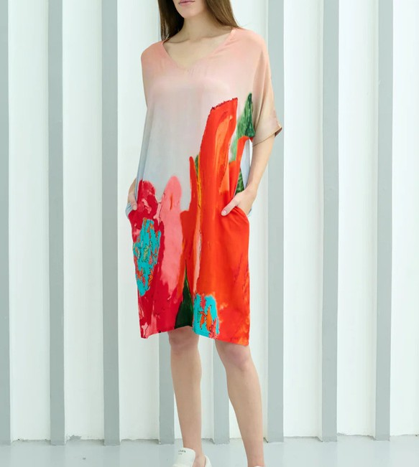
The product

www.dharasheth.ae

Summer Collection
Discover the ultimate in summer sophistication with the Dhara Sheth Summer Collection. Crafted from breathable fabrics and adorned with refined details, this curated range brings together lively colours, abstract motifs, and modern shapes.
Whether you’re headed to a seaside escape, an
evening partyies, or everyday indulgence, these pieces deliver unmatched comfort and standout style.
Summer 2026

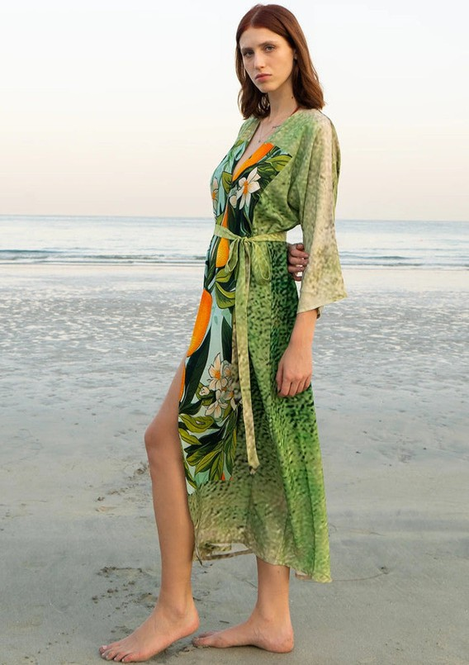
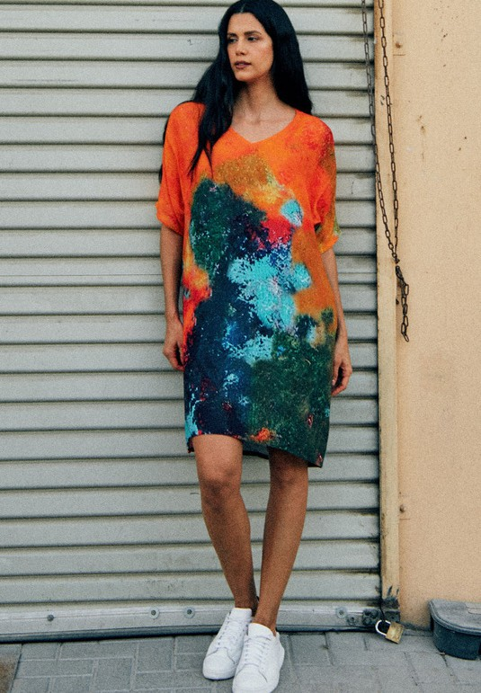
www.dharasheth.ae

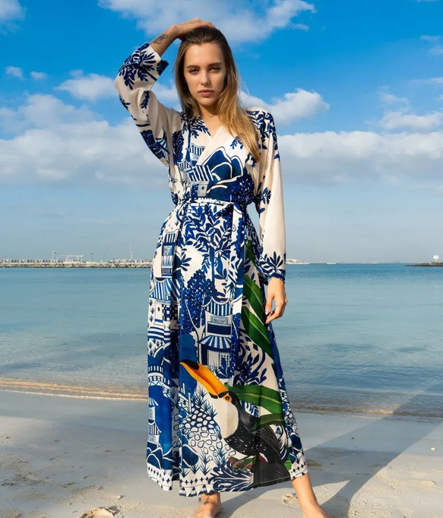
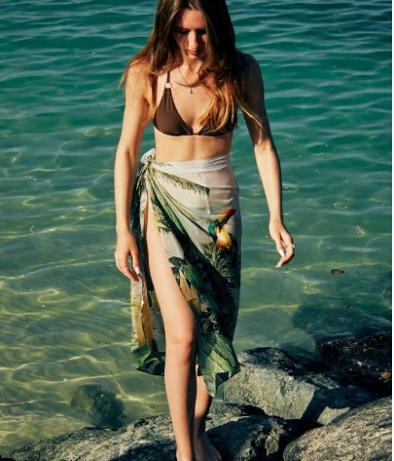
Related Products

Spaghetti Strap Dresses- https://www.dharasheth.ae/collections/spaghetti-strap- dress-1
Spring/Summer 25- https://www.dharasheth.ae/collections/spring-summer-25

Canvas & Chaos- https://www.dharasheth.ae/collections/canvas-chaos

Fleur & Fruit- https://www.dharasheth.ae/collections/citrus-crush

www.dharasheth.ae


contact us
Stay in touch
+971 50 252 7123
info@dharasheth.ae @dharashethdubai

www.dharasheth.ae


Thank You

Thanks
www.dharasheth.ae

